TRƯỜNG THCS PHAN CÔNG HỚN
TỔ TIẾNG ANH
TIẾNG ANH 6
TUẦN 22 (TỪ 10/02/2025 ĐẾN 15/02/2025)
WEEK 22
PERIOD 64+65+66: UNIT 7: MOVIES
Lesson 1-1 (New words)
- New words:
- comedy (n) /ˈkɒm.ə.di/ : phim hài
comedian (n) /kəˈmiːdiən/ : diễn viên hài
- science fiction (n) /ˌsaɪəns ˈfɪk.ʃən/ : phim khoa học viễn tưởng
- horror (n) /ˈhɒr.ər/ : phim kinh dị
- action (n) /ˈæk.ʃən/ : phim hành động
act (v) /ækt/ : diễn xuất
acting (n) /ˈæktɪŋ/ : việc diễn xuất
actor (n) /ˈæktə(r)/ : diễn viên nam
actress (n) /ˈæktrəs/ : diễn viên nữ
- drama (n) /ˈdrɑː.mə/ : phim chính kịch
dramatic (adj) /drəˈmætɪk/ : kịch tính
- animated (adj) /ˈæn.ɪ.meɪ.tɪd/ : hoạt hình
animation (n) /ˌænɪˈmeɪʃn/ : hoạt hoạ

- Choose the best option (A, B, C or D) to complete each of the following sentences.
1. The movie was so __________ that I smiled at the end.
A. awful B. funny C. fantastic D. terrible
2. Alex can’t watch __________ movies. He thinks they’re too scary and he always has bad dreams after watching them.
A. comedy B. action C. horror D. drama
3. Rowan Atkinson is a famous _________. His famous character is Mr. Bean.
A. act B. acting C. actor D. actress
4. I __________ to make a sandwich this morning but it __________ horrible.
A. try/ was B. try/ is C. tried/ is D. tried/ was
5. My brother enjoys watching _________ movies although he feels scared of haunted houses and mysteries.
A. science fiction B. horror C. animated D. comedy
6. Tom and Jerry is a/an _________ movie. The characters are drawings, not real people.
A. science fiction B. drama C. action D. animated
7. Susie loves acting so she wants to be a _________ when she grows up.
A. dancer B. farmer C. teacher D. actress
8. A lot of exciting things happen in this kind of movie.
A. drama B. action C. animated D. science fiction
9. We like __________ movies. They’re about space and the future.
A. horror B. drama C. science fiction D. comedy
10. Do you want to see a film on Saturday?
A. Yes, I will. B. Sounds great. C. No, I didn’t. D. I didn’t see it.
III. Write a suitable word for each picture.
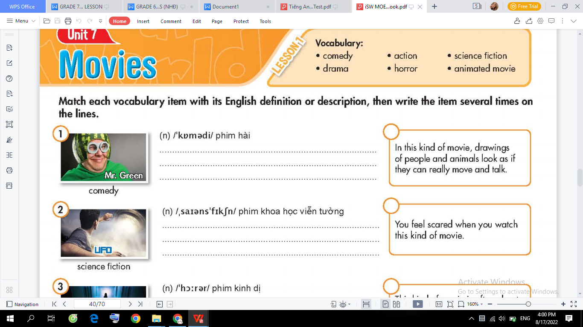 | 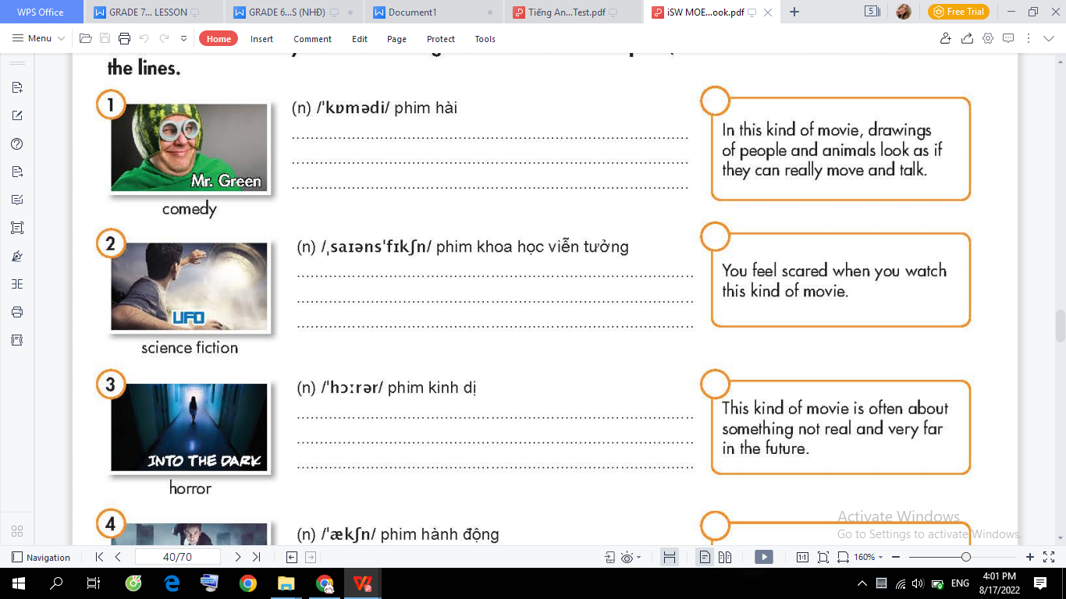 | 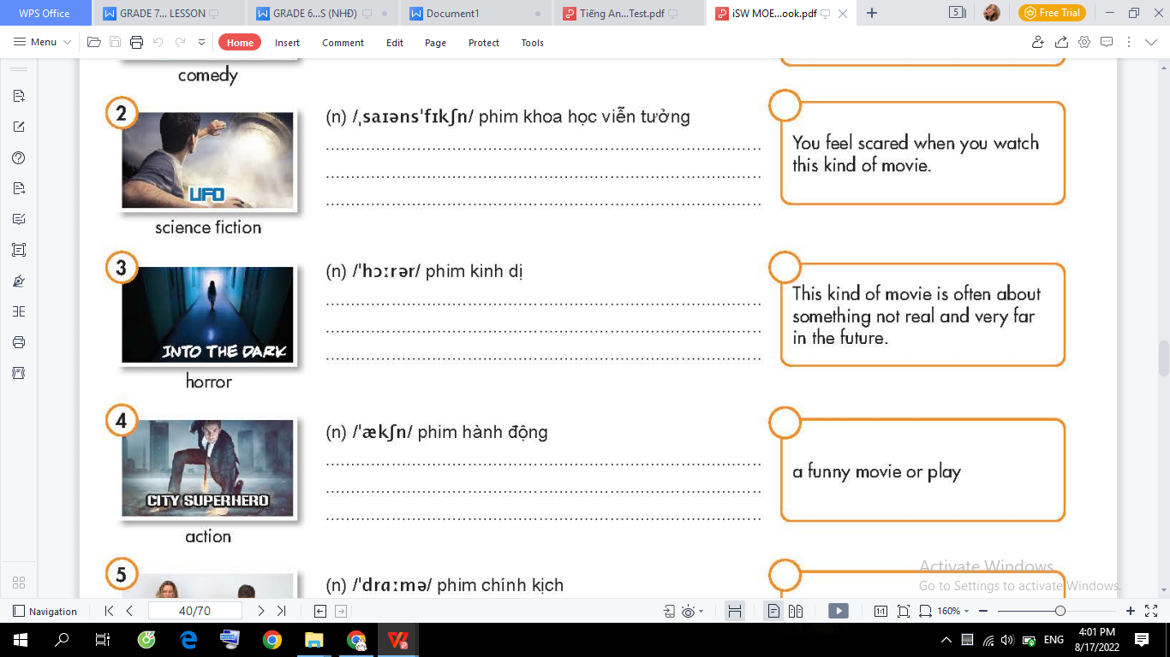
_________________ | _________________ | _________________
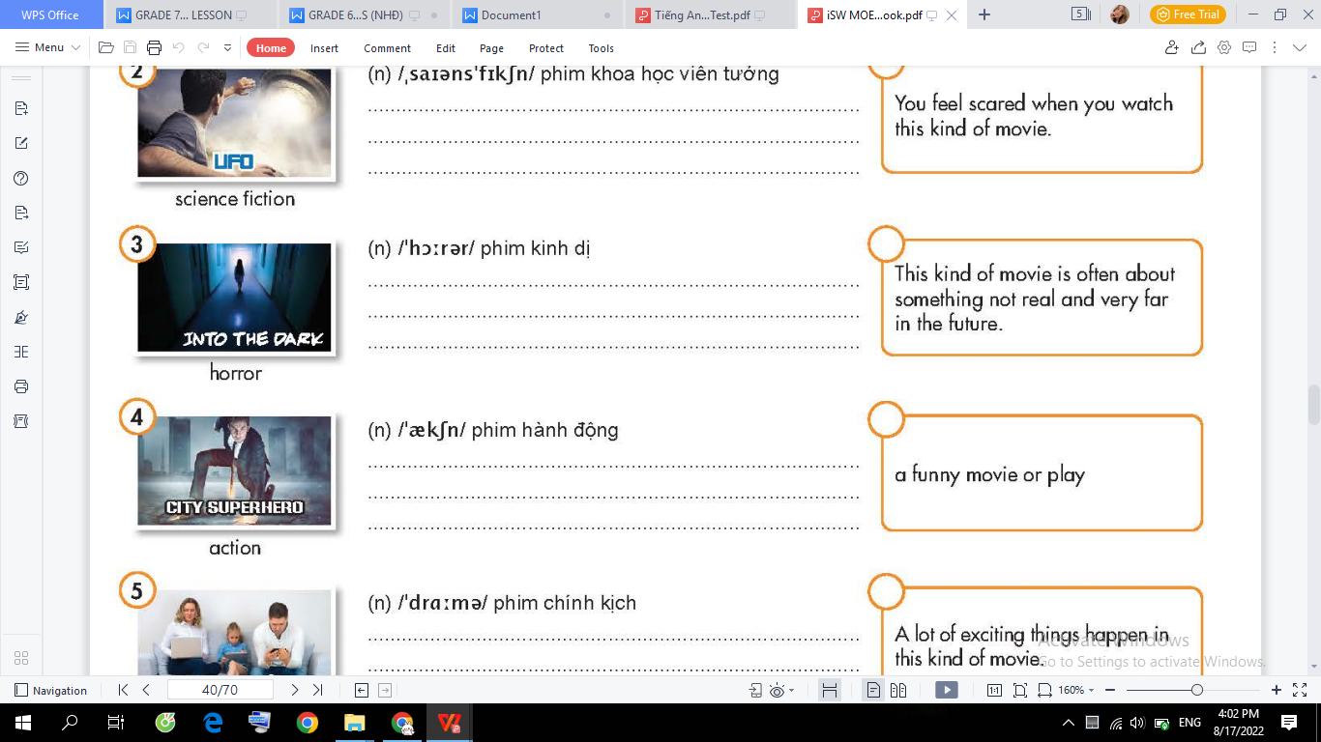 | 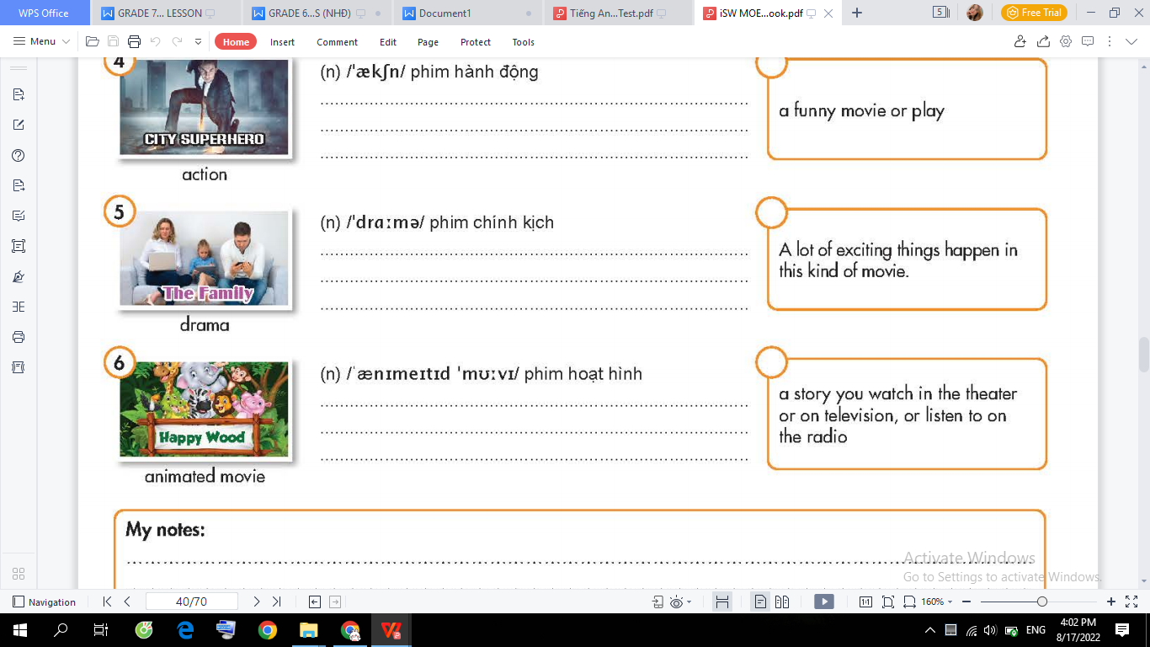 | 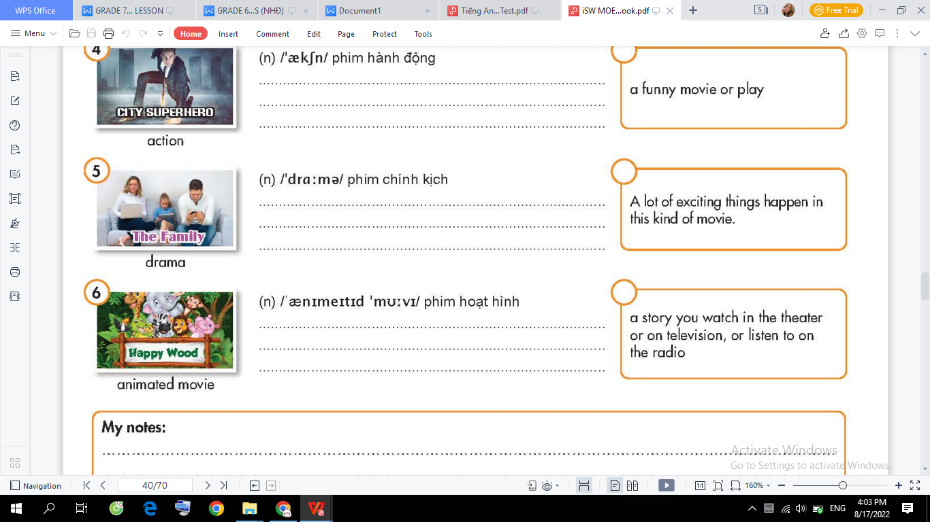
_________________ | _________________ | _________________

⁕⁕⁕⁕⁕

UNIT 7: MOVIES
Lesson 1-2 (Grammar)

- Grammar: Prepositions of time
Prepositions of time | Usages and Examples
on | Use with days, dates, and parts of a specific day:  - The movie is on Saturday.  - Are you free on Friday afternoon?  - Do you want to see a movie on October 6?
at | Use with specific time:  - What time is the movie? It’s at 6 p.m.
in | Use with parts of the day, months, seasons and years:  - I watch a lot of movies in the winter.  - Do you want to see a movie in the evening?  - You can see this movie at the theater in March.  - My sister is going to Russia in 2025.

- Write a suitable preposition in the blank.
- Mary’s birthday is ______ January.
2. We often go out _______ Saturday evenings and come back home at 11 __________ night.
3. My English class always starts ________ 8 o’clock.
4. In Canada, it always snows _______ the winter.
5. What time do you usually get up? - I usually get up ______ 6 a.m.
- Let’s go to the swimming pool _______ Sunday morning.
- We’ll take a vacation to Italy _______ December.
- I never drink coffee _______ night. However, I always drink milk ________ the morning.
- She always visits her parents ________ Christmas Day.
- ________ 2050, people might live on Mars.

- Put the times in their correct category.
the morning Sunday noon spring
my birthday 10:30 May 5th the weekend
- Monday evening night November
half past seven winter Tuesday afternoon the 19th century

at | on | in

UNIT 7: MOVIES
Lesson 1-3 (Pronunciation)

- Find the word whose underlined part differs from the other three in pronunciation.
1. A. performance B. comedy C. terrible D. September
2. A. magic B. acting C. fantasy D. island
3. A. novel B. soccer C. role D. comic
4. A. parks B. schools C. theaters D. museums
5. A. boxes B. dishes C. gloves D. Kisses

- Choose the word that has a different stressed syllable from the rest.
- A. doctor B. student C. engineer D. designer
2. A. comedy B. drama C. fiction D. cartoon
3. A. documentary B. channel C. cartoon D. comedy
4. A. money B. ticket C. audience D. performance
5. A. beautiful B. interesting C. awesome D. Amazing

- Write the correct form of the words in the brackets.
1. It is a very ______________ movie with lots of laughter and the ending is hilarious. (FUN)
2. I love watching ______________ movies. My favorite one is Doraemon. (ANIMATION)
3. I like the film at all. It was so ______________. (INTEREST)
4. The movie was so ___________ that I cried a lot. (SADLY)
5. Horror movies are very ____________ so I don’t usually watch them. (SCARE)

- Put the words in the correct order to make correct sentences.
1. are/ going/ We/ the/ to/ cinema/ this weekend/ .//
_______________________________________________________
- funny/ Mr. Bean/ is/ animated/ a/ movie/ .//
_______________________________________________________
- There’s/ new/ a/ drama/ TV/ tonight/ on/ .//
_______________________________________________________
- movie theater/ seven o’clock/ Let’s/ at/ meet/ in front of/ the/ .//
_______________________________________________________
- go/ family/ My/ in/ camping/ usually/ the/ summer/ .//
_______________________________________________________

